Python code for psychrometer

A psychrometer is used to measure relative humidity using two thermometers: a wet bulb and a dry bulb. Here’s a Python code that calculates relative humidity based on the temperature readings from both thermometers.

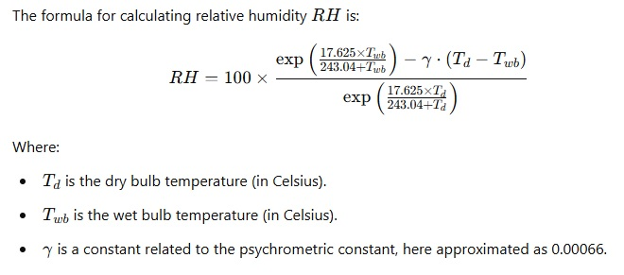

Here's the code:

*import math*

*def calculate_relative_humidity(dry_bulb_temp, wet_bulb_temp):*

*# Constants*

*gamma = 0.00066 # psychrometric constant (approximation)*

*# Calculate the saturated vapor pressure for the wet and dry bulb*

*e_wet = math.exp((17.625 * wet_bulb_temp) / (243.04 + wet_bulb_temp))*

*e_dry = math.exp((17.625 * dry_bulb_temp) / (243.04 + dry_bulb_temp))*

*# Calculate actual vapor pressure and relative humidity*

*actual_vapor_pressure = e_wet - gamma * (dry_bulb_temp - wet_bulb_temp)*

*relative_humidity = (actual_vapor_pressure / e_dry) * 100*

*return relative_humidity*

*# Example usage*

*dry_bulb_temp = 25.0 # dry bulb temperature in Celsius*

*wet_bulb_temp = 20.0 # wet bulb temperature in Celsius*

*rh = calculate_relative_humidity(dry_bulb_temp, wet_bulb_temp)*

*print(f"Relative Humidity: {rh:.2f}%")*

Explanation:

* dry_bulb_temp is the temperature of the dry thermometer.
* wet_bulb_temp is the temperature of the wet thermometer.
* The function calculate_relative_humidity calculates the humidity using the formula provided.